Published on Office of the Chief Information Officer (https://ocio.wa.gov)

Home > Policies > 141 - Securing Information Technology Assets > 141.10 - Securing Information Technology Assets Standards > 141.10 Appendix B - IT Security Risk Threatscape

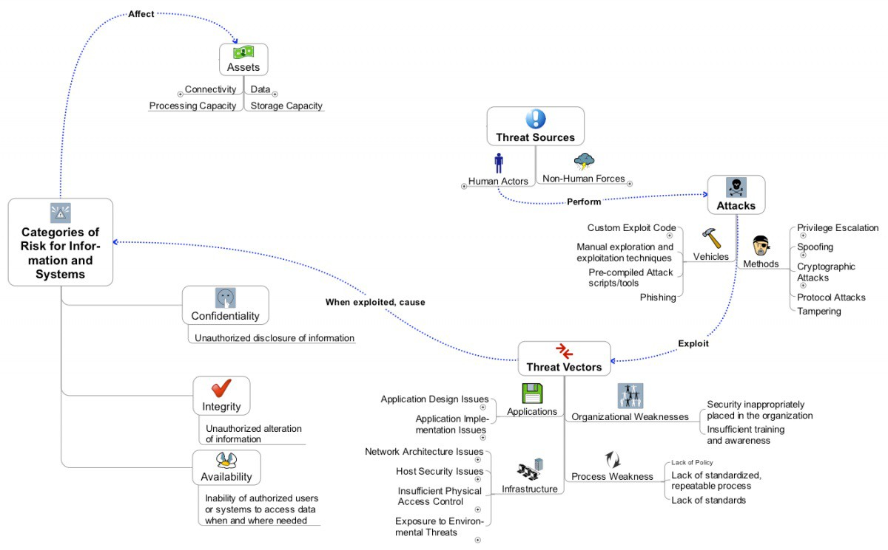

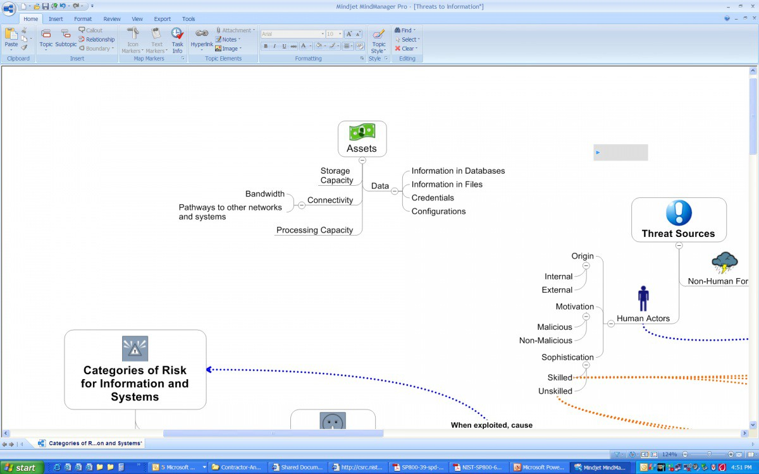

"""'

Tb

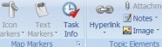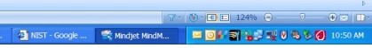Mlndjet /r.lindMaNger Pro (ThrNUto tifo,rnatlof'l•j

Export Toal!i "'' - - y
../ AA>d·

T StJbtoplc: Q
"""'

Bandwidth-

IAssets
'

Information in Databases
IJ - A . - J .. a- i.:_;...,.i ;;;.
roe :anriq ,. Styt- .
J( "C>"o"<"·
E""'J

r networks )..= Connectivity

Processing Capacity •
Information in Files Credentials Configurations

Storage Capacity

Origin ­
Internal--- f

Threat Sources
1

4-Accidental Damage

External

Motivation
'::)
1

Malicious -

Human Actors

Non-Human Forces
Natural Disasters

System Failure

Non-Malicious

················································....
····...

fConfientiality J

....

·.............

Sophistication

Skilled 1 Unskilled

Whenexpioited, cause

--
Unauthorized disclosure of
inf,..,m.,ti""

........

liimAMU•JJ .q:.eif.11¥·'·i!.*31 Mt.i.!ii.+,Hi.ii·· +@!...:u1d

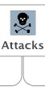.............................................................

Vehcles Methods

Viruses

Custom Ex loit Code

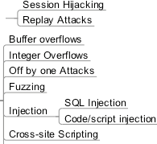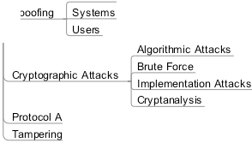Session Attacks

Manual explo­ ration and ex­
ploitation tech-

In ut Allacks

Human Actors

Pre-rompiled Attack
sc ri ts/ tools Privil e Escalation Phlshin

Cross-site Reguest Forg­ Man in the Middle

Attacks

Brute Force
Credential Stealin RainboN Tables
L!:'.c !!!.! crackin"-iAl orithm attacks

SocialEn ineering Phishing

Connections/Data

s

Protocol Attacks

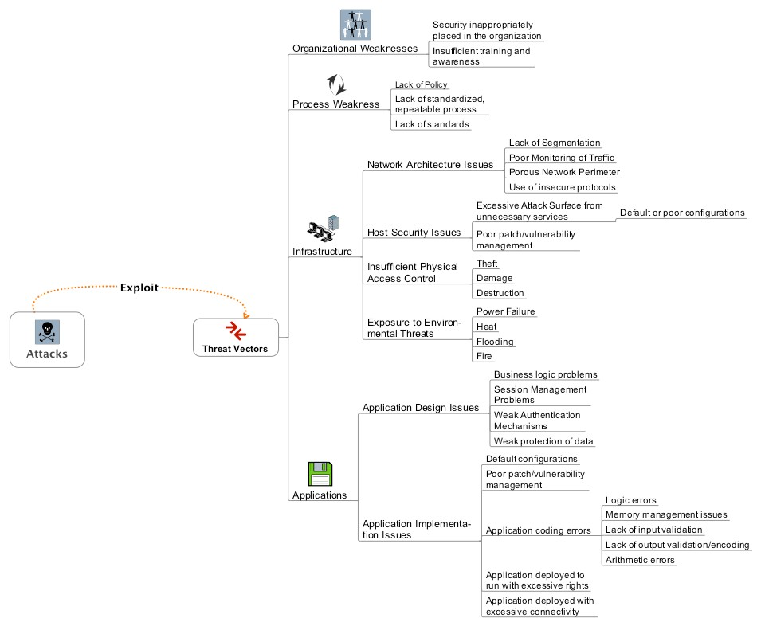

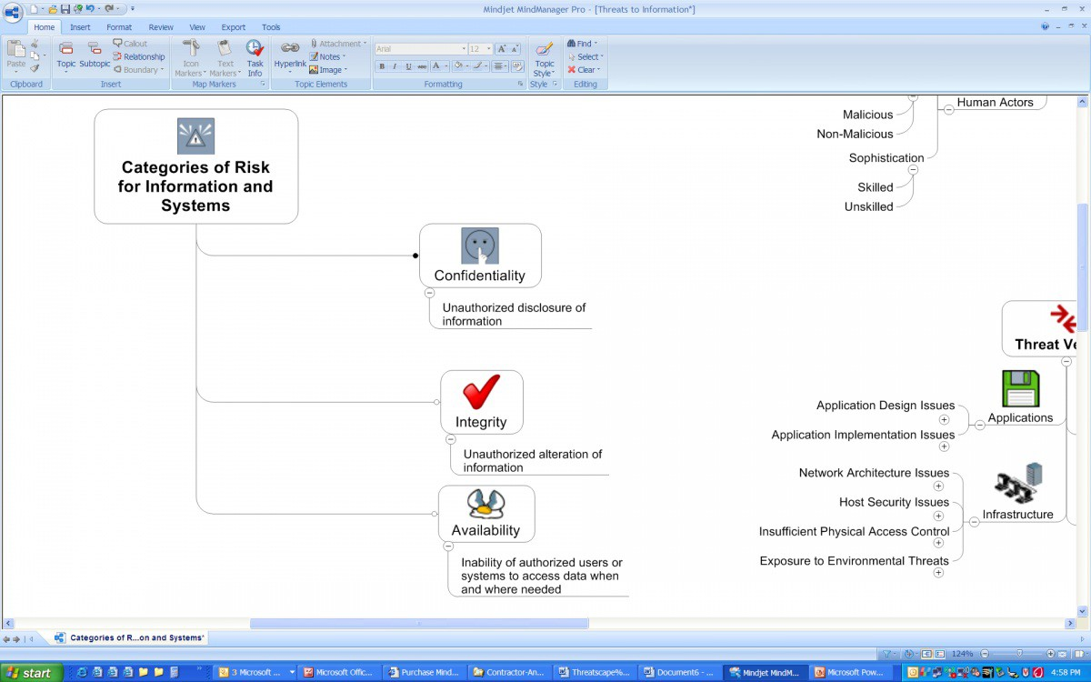

Source URL: https://ocio.wa.gov/policies/141-securing-information-technology-assets/14110-securing-information-technology-assets-2

