Published on Office of the Chief Information Officer (https://ocio.wa.gov)

Home > Policies > 185 - Establishing an Enterprise Service

INTRODUCTION

The Office of the Chief Information Officer (OCIO) has the statutory responsibility for “developing evaluation criteria for deciding which common enterprise-wide business processes should become managed as enterprise services” or systems. RCW 43.105.265 [1]

Lean methods teach us that a key to reducing waste is to adopt standard work processes. If data or business processes are similar across state government agencies, it is important to consider whether standardization could provide efficiencies or enable new capabilities for the enterprise. In Washington, data, business processes and technologies are required to be standardized across the enterprise only when there is clear justification.

This policy is written in the context of starting a new service. It can also be applied to existing services, or to the current stage of a service under development.

PURPOSE

The policy defines an Enterprise Service and lays the foundation for governance, decision making and agency involvement in services or systems with statewide significance.

Establishing a service as an Enterprise Service early in its lifecycle enables the service to reasonably assume a large customer base and a more predictable agency adoption rate from the beginning of the project. This enables:

The service to derive economies of scale and/or efficiencies from subsequent planning, analysis, and decision making. Customer agencies to provide input to the service and participate in decisions from the beginning.
The Business or Service Owner to make the large initial investment in a service with the understanding that agencies will join at an agreed upon rate.

DEFINITIONS

Enterprise Service: An enterprise service is a service that all state government agencies with a certain business need or process are required to use, unless they have received a waiver as described in the Waivers and Appeals section below. Agencies must not adopt a similar service unless they have this waiver.

Types: Enterprise Services can support common administrative business processes such as accounting, payroll, etc., or they can include Information Technology applications or services commonly used by agencies.

Criteria to Establish an Enterprise Service: The following criteria must be satisfied to establish an Enterprise Service:

There is a need to collect standard data across agencies, and/or
It is feasible to define and develop a standard business process across state government agencies

Business Owner: The agency accountable and/or responsible to make policy or business decisions regarding an Enterprise Service. The business owner convenes a governance body to provide oversight and represent agencies’ business needs. Some Enterprise Services also have a service owner.

Service Owner: The service owner is the agency that implements the business owner’s decisions and plans, and performs many of the service’s implementation and operational activities.

State Government Agencies: Every state office, department, division, bureau, board, commission, or other state agency, including offices headed by a statewide elected official. Institutions of higher education are included when an Enterprise Service applies to business or administrative applications or services, but not to academic, research, medical, clinical or health care applications, including the business and administrative applications for such operations. The legislature and the judiciary are not included, but are strongly encouraged to coordinate with the OCIO and participate in enterprise-based strategies and services.

POLICY STATEMENT

How an Enterprise Service is established:

Justification Approval or Disapproval

The state Chief Information Officer (CIO) makes the determination whether a service should be established as an Enterprise Service. Approval establishes an Enterprise Service. The state CIO, at his/her discretion, will normally appoint an ad hoc advisory group to evaluate the justification from the business owner for the service to be enterprise and recommend approval or disapproval to the state CIO. The advisory group’s membership will consist of the state CIO, the Deputy Director of the Office of Financial Management, and representatives of two or more prospective customer agencies of the proposed enterprise service. The OCIO will list established enterprise services on its website and notify agencies when a new service is under consideration [2] or has been established. Established services will be identified as 185.xx and
linked to from the Policy 185 resource area.

The Timing for Enterprise Service Justification in the Development Lifecycle

The justification for a new Enterprise Service is made early in the development lifecycle, before most of the business and technical analysis for the business case is completed and well before final feasibility decisions are made. (See Figure 1 below) This enables the service to reasonably assume a large customer base from the start and derive economies of scale and/or efficiencies from subsequent planning, analysis, and decision making. This also enables agencies to provide input and participate in decisions from the start.

Important issues or risks may surface in later steps of the development cycle that impact the Enterprise Service’s justification, business case, development, or operations. These must be resolved at the proper time for the service to proceed through subsequent go/no-go decision gates and retain its Enterprise Service designation.

Justification Contents

The justification should only contain enough information to clearly justify why a certain business process, data and/or the supporting technology should be declared “standard,” or the same, across agencies. Topics to address could include:

How the above criteria to establish an Enterprise Service are satisfied

A clear description of the proposed Enterprise Service, including the underlying business process, data, and/or technology The business problem to solve or the opportunity to gain
Laws or regulatory requirements that apply across agencies Other business drivers that apply in the circumstance

The type of information needed to make this justification may vary for each service based on the circumstances and the level of justification needed to reach agreement in the approval process. At this early stage, cost is not necessarily a deciding factor in the justification as it will be in subsequent steps of the development cycle. The justification should be based on the facts, best estimates, and assumptions available at the time. It is developed with input and collaboration from prospective customer agencies. It includes known requests for waivers, which are described in the Waivers and Appeals section below.

Initiating an Enterprise Service

Enterprise Services can be initiated in several ways:

- An agency identifies a common business need, takes on the business owner role, builds support, and requests approval of the justification for an Enterprise Service.
- An agency wants to build or acquire an agency-specific system, but the OCIO determines it should become an Enterprise Service. A business owner is identified, then pursues justification approval.
- A group of agencies identify a common business need, select a business owner or jointly assume that role, and pursue justification approval. The OCIO justification approval may include qualifying the proposed agency for the business owner role.

How Decisions are made in Enterprise Service Development and Operations:

Enterprise service governance is modeled after traditional IT governance structures, but the scope of Enterprise Service governance is broader.

Governance bodies will be established to make recommendations on all phases and aspects of each Enterprise Service, consider requests, and with the business owner, drive the work to achieve expected business outcomes. Members are recruited by the business owner to provide broad representation across the customer
base. These agency business representatives provide an increased level of user participation with the business owner in decision making. Members promote increased coordination and collaboration across agencies to achieve expected results.

This ensures due diligence is exercised in decisions on the development and operation of the service, and that business needs are met. Over the life of the service, lifecycle decisions must be made to address changing business drivers and market conditions. To ensure that a service remains viable, factors such as changes to external regulations, service improvement opportunities, technology trends and/or prices may be considered.

If necessary, final decisions on the Enterprise Service’s business case, development, and operations will be made by the business owner after balancing available factors and input. Appeals to these decisions may be made according to the Waivers and Appeals section below.

Timelines for Agency Adoption

The adoption timeline for each agency to use an Enterprise Service is developed by the business owner with the agency and the governance body. Appeals to these decisions may be made according to the Waivers and Appeals section below. The proposed agency adoption timeline must include the following at a minimum:

Triggers for agency adoption. Examples could include agency investments for maintenance, enhancements, replacement, or acquisition of a similar system. Overall strategy for adoption.
Planned pace of adoption.
Total planned duration for adoption by all agencies in scope. Barriers to adoption.

Supplementary Systems

If supplementary systems are needed and an agency is approved by the business owner to operate one, the agency will pay for the system and support the Enterprise Service’s standards for system interfaces and data quality. Appeals to these decisions may be made according to the Waivers and Appeals section below.

WAIVERS AND APPEALS

Processes for waivers and appeals are necessary since Enterprise Service establishment, development and operations have broad impacts on agency participation, business processes and data.

Waivers on Agency Participation in Enterprise Services

Once an Enterprise Service is established, all state agencies with that business need or process are required to use that service unless they have a waiver from the
state CIO. The OCIO will document the process for granting a waiver. The state CIO’s decision regarding the waiver may be appealed to the Technology Services Board (TSB).

Process to Appeal Decisions on Enterprise Service Development and Operations

Agencies that will use an Enterprise Service are encouraged to participate in decision making through the service’s governance body. Each Enterprise Service must include an appeal process in the service’s governance. This process is used to appeal decisions of the business owner or the governance body regarding the Enterprise Service’s business case, development or operations.

RESPONSIBILITIES

Chief Information Officer (or designee)

Approve or disapprove an Enterprise Service justification Approve or disapprove agency waivers
Oversee project development for major IT projects according to OCIO policy Enforce compliance with this policy
Approve or disapprove the proposed IT investment Promote adoption of established Enterprise Services

Agency Heads

Support agency adoption of established Enterprise Services
Allocate agency resources for Enterprise Service planning and decision-making

Technology Services Board

Review and approve all major policy changes Review and approve major IT projects

RELATED LAWS AND OTHER RESOURCES

According to RCW 43.105.265 [1], the OCIO is responsible to develop:

A roadmap of priorities for creating Enterprise Services Evaluation criteria to establish Enterprise Services
Evaluation criteria to continue, hold or drop related technology investments

According to RCW 43.105.245 [3], the OCIO reviews and approves major technology projects and services.

- Prior to making a commitment to purchase, acquire or develop a major information technology project or service, state agencies must provide a proposal to the office outlining the business case of the proposed product or service, including the up-front and ongoing cost of the proposal.
- Within 60 days of receipt of a proposal, the office shall approve the proposal, reject it or propose modifications.
- In reviewing a proposal, the office must determine whether the product or service is consistent with:
  - the standards and policies developed by the office pursuant to RCW 43.105.054 [4]; and
  - the state's enterprise-based strategy.
- If a substantially similar product or service is offered by the Consolidated Technology Services (CTS) agency established in RCW 43.105.047 [5], the office may require the agency to procure the product or service through CTS, if doing so would benefit the state as an enterprise.
- The office shall provide guidance to agencies as to what threshold of information technology spending constitutes a major information technology product or service under this section.

OCIO Policy 121 – Information Technology Investments - Approval and Oversight - Procedures [6] - During the conceptual review of a new agency project, the OCIO may determine that the system or service should become an Enterprise Service. Common administrative business processes such as accounting, payroll, etc., or common IT applications or services used by many agencies could be candidates for an Enterprise Service.

OCIO Policy 131 - Managing IT Projects Policy [7]

OCIO Policy 141 - Securing IT Assets Policy [8]

OCIO Standard 141.10 - Securing IT Assets Standards [9]

REVISION HISTORY

Date | Action taken
June 6, 2014  April 23, 2014 | Added Procedures.  Added language to the Timelines for Agency Adoption section as discussed with the TSB Policy Sub-committee.  New Policy adopted.

CONTACT INFORMATION

For questions about this policy, please contact the OCIO [10].

APPROVING AUTHORITY

/s/ Michael Cockrill April 23, 2014
Chief Information Officer Date
Chair, Technology Services Board

Figure 1

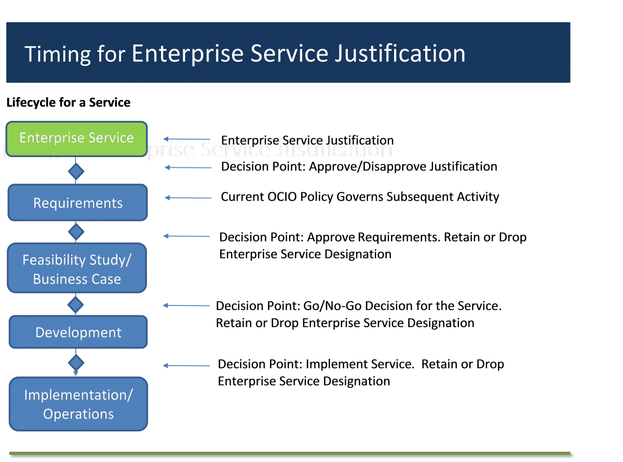

Source URL: https://ocio.wa.gov/policies/185-establishing-enterprise-service

Links:
[1] http://apps.leg.wa.gov/rcw/default.aspx?cite=43.105.265
[2] https://www.ocio.wa.gov/policies/185-establishing-enterprise-service/requests-establish-enterprise-service
[3] http://apps.leg.wa.gov/rcw/default.aspx?cite=43.105.255
[4] http://apps.leg.wa.gov/rcw/default.aspx?cite=43.105.054
[5] http://apps.leg.wa.gov/RCW/default.aspx?cite=43.105.047
[6] https://www.ocio.wa.gov/policies/121-it-investments-approval-and-oversight/121-procedures#concept-review
[7] https://www.ocio.wa.gov/policies/131-managing-information-technology-projects
[8] https://www.ocio.wa.gov/policies/141-securing-information-technology-assets
[9] https://www.ocio.wa.gov/policies/141-securing-information-technology-assets/14110-securing-information-technology-assets
[10] http://ocio.wa.gov/it-consultants
[11] https://www.ocio.wa.gov/policies/185-establishing-enterprise-service/185-procedures
[12] https://ocio.wa.gov/policies/enterprise-service-enterprise-active-directory-office-365-tenancy

