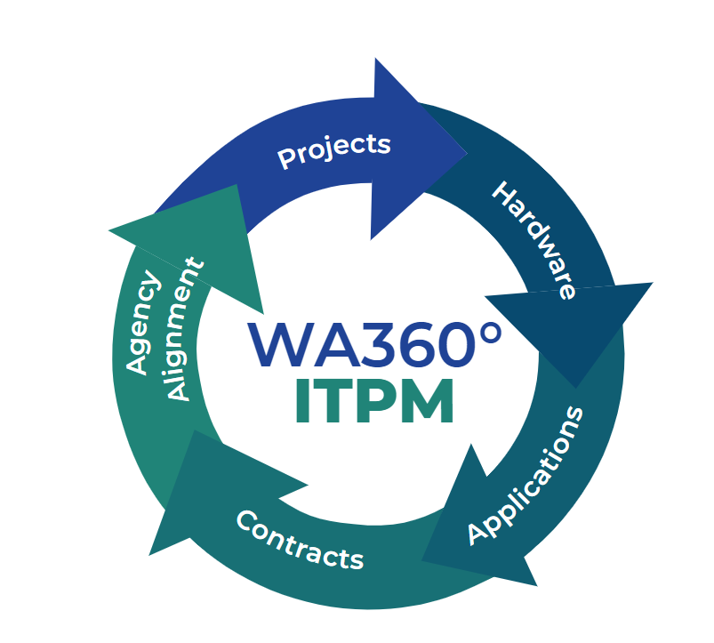

IT Portfolio Management Business Owner’s Guide

11 May 2023

Jeremy Schlake

##### 

**Table of contents**

Chapter 1: Introduction to WaTech’s IT Portfolio 3

What is the purpose of the Business Owner Guide? 3

What is WaTech’s IT portfolio? 3

Chapter 2: Business Owner Responsibilities 4

What is needed from the Business Owner? 4

What are the current ITPM inventory databases? 5

Chapter 3: ITPM Program Manager Expectations 5

What should you expect from the ITPM Program Manager? 5

ITPM Program Manager annual review timelines 6

ITPM Program Maturity Efforts 6

# Chapter 1: Introduction to WaTech’s IT Portfolio

## What is the purpose of the Business Owner Guide?

IT Portfolio Management (ITPM) is the ability to take the provided central view of the agency's strategy, plans, governance, projects, investments, and resources and enhance the ability of key decision-makers to develop and refine strategies which direct resources and spending towards those investments that best support the agency's mission and business objectives. The ITPM program requires a continuous flow of information from business owners that maintain internal IT inventories to provide a strategic-level understanding of the overall inventory for the agency. This in turn allows the ITPM program to improve efficiency and effectiveness of the IT portfolio to better meet agency goals and objectives.

The ITPM Business Owner Guide is designed to provide governance of what is the WaTech IT portfolio and ITPM program, what business owners are responsible for towards implementation of the ITPM program, and what business owners should expect from the IT portfolio manager.

## What is WaTech’s IT portfolio?

The WaTech IT Portfolio provides a centralized view of the agency's strategy, plans, governance, projects, investments, and resources. It also documents the current allocation of resources supporting the agency’s mission, programs, and business objectives. The portfolio approach allows WaTech to manage its investments and resources more effectively. The use of technology is prevalent throughout the agency, portfolio information is increasingly important for executive and management decision making. The information enhances the ability of key decision-makers to develop and refine strategies which direct resources and spending towards those investments that best support the agency's mission and business objectives. The WaTech internal IT Portfolio and TBM program is also performed within the Strategy and Management Division (SMD).

Figure : WaTech's ITPM Overview

The strategic ITPM framework must include all aspects of the organization’s IT portfolio.  While existing guidance on the appropriate elements for portfolio management include a definition of business objectives, an inventory of projects, a prioritization of projects, a review of the feasibility of the projects, and then managing and monitoring of the portfolio does well on ensuring the efficient use of business finances regarding projects, it fails to capture the entire collection of IT resources available to organization.

To better capture the IT portfolio, the following elements should be collected and analyzed in the progression of maturing an organization’s IT portfolio: overview of business objectives and how the parts of the portfolio are aligned with the organization, current policies, inventory of current and planned projects, inventory of current applications, inventory of current hardware, current and future budgetary trends, and the association of the inventoried assets and investitures with current stakeholders.  These elements help produce a holistic IT portfolio that will best improve the organization’s governance.  Outlining these elements is helpful to better assemble a full portfolio.

# Chapter 2: Business Owner Responsibilities

## What is needed from the Business Owner?

WaTech Business Owners each maintain their separate division’s internal business. Part of these processes require inventory accountability and proper application and infrastructure management to provide responsible execution and maintenance of State government assets and associated funding. Knowing the information that is required to fulfill these processes is vital to success at meeting these goals. This is where the ITPM program comes into effect. The ITPM program details what information must be fulfilled to best capture if State assets and funding are being properly enacted and maintained in accordance with legislation and policies.

Business Owners at WaTech will provide annually updated metrics on project inventory, application inventory, hardware inventory, contract inventory, and IT stakeholders in their respective divisions. Most metrics for inventory information are updated in the existing Microsoft Teams files for annual collection. The same applies to contract inventories for the agency.

The ITPM Program requires frequent input and updates from business owners. To effect these requirements, the following items are some of the inputs that business owners should provide the ITPM program to ensure compliance with [OCIO Standard 112.10](https://ocio.wa.gov/policy/technology-portfolio-foundation-applications), [OCIO Standard 112.20](https://ocio.wa.gov/policy/technology-portfoliio-foundation-infrastructure), [RCW 43.105.230](https://app.leg.wa.gov/RCW/default.aspx?cite=43.105.230), and [RCW 43.105.341](https://app.leg.wa.gov/RCW/default.aspx?cite=43.105.341).

* Inventory additions or removals from the central inventory database
* Informational updates to the central inventory database
* Annual reviews and acceptance of current inventory levels
* Identification of goals and objectives for using IT within their realm of responsibility
* Up-time rates of current IT assets
* Internal governance documents

## While it is best practice to provide inputs and updates as changes happen to avoid loss of information and improve reliability in real time, WaTech governance requires only annual review and input of inventory changes and approval of business owner inventory. Inventories and stakeholder engagement must be reviewed and validated in this way by the business owner through their technical owners. Business owners must also resolve any discrepancy with their inventory with the ITPM manager to ensure preservation of informational integrity and reliability. What are the current ITPM inventory databases?

The current inventory is stored on the WaTech-OCIO Reports Teams SharePoint site. The directory navigation is found under “General > WaTech Annual Certification Documents” and then stored in the respective year for the inventory certification. Navigating into the “(year) WaTech Technology Certification Artifacts > (year) inventory” folder will give the business owner access to the Excel spreadsheet for the annual inventory certification. The ITPM program manager and the Washington Enterprise portfolio manager are the only two individuals that can provide access to the files for change and is the primary security feature to ensure information security.

# Chapter 3: ITPM Program Manager Expectations

## What should you expect from the ITPM Program Manager?

**Analysis**

The ITPM Program Manager will provide analysis to each business owner in WaTech. This function is designed to take all the inventory and policy from the business owners and review that information in order to satisfy OCIO Policy 112 requirement to “…establish an IT strategic plan in support of the agency business plan and in alignment with the state’s strategic plan.” Without a full complement of information supplied by the business owners, the ITPM program manager is unable to meet this requirement.

**Reports**

The ITPM program manager, while working to provide a sound strategy for the use of IT assets within the agency to the OCIO, is responsible for the communication to each business owner of how their specific division is performing within legislative direction, state regulations, and agency policies. The ITPM program manager will at times publish reports separated into each division for targeted information purposes to achieve this goal and provide those reports to the business owners for program maturity efforts.

**Advise**

Along with reviewing received informational inputs and communicating report agency status to each business owner and the OCIO, the ITPM program manager will provide third-party advice to all associated stakeholders on ways to best utilize IT resources within WaTech. This advice is not limited to any one area of IT governance and while it is designed to find best practices and direction that best affects IT strategic alignment it is only recommendations that are not required to be followed. The burden to support all IT resource recommendations falls upon the ITPM program manager and the program manager must do so with a firm enough position.

## ITPM Program Manager annual review timelines

Annual inventory is due to the State Enterprise Portfolio Manager by September 30. Inventory reviews are officially required by the WaTech ITPM Program Manager by August 30.

## ITPM Program Maturity Efforts

Continual Process Improvement of the ITPM Guide and Business Owner’s Guide.

Establishing the agency governance over the program and schedule review processes of the program.

Training in the form of proper disposition of ITPM duties and business owner responsibilities.

Expansion of ITPM program automation.