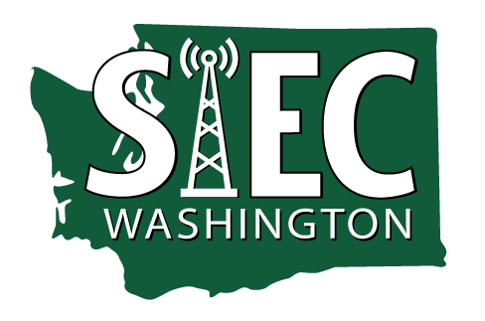 |  | AGENDA  State Interoperability Executive Committee  Hybrid Meeting  April 11, 2023 | 10:00 AM – 12:00 PM  Location:  1500 Jefferson St. SE, Olympia, WA 98504 | 1st Flr Conf Rm 1213  or  Join Zoom Meeting  Join by phone 1-253-215-7799 | Access code: 999 6052 5038#
Separate documents or attachments are also found on this website.
Refers to decisions required.

10:00-10:05  10:05-10:25 | Time for Zoom log-in and Test audio  Call to Order, Welcome, and Introductions  - Review agenda  - News and Information Roundtable  - Approval of October 20, 2022 meeting minutes  - Approval of February 14, 2023 meeting minutes |  | Bill Kehoe, Chair  SIEC Members
10:25-10:55 | Puget Sound Emergency Radio Network (PSERN) |  | David Mendel, King County
10:55-11:15 | SCIP Document  - Overview  - Projects and Timelines  - Motion to approve |  | Bill Kehoe, Chair
11:15-11:25 | SAW Group Updates |  | Anton Damm, SAW Chair or Daniel Hypes
11:25-11:45 | Cybersecurity Grant Updates |  | Zack Hudgins, Vice-Chair
11:45 | Good of the Order and Public Comments |  | All

